Exhibitor’s declaration of intent to exhibit
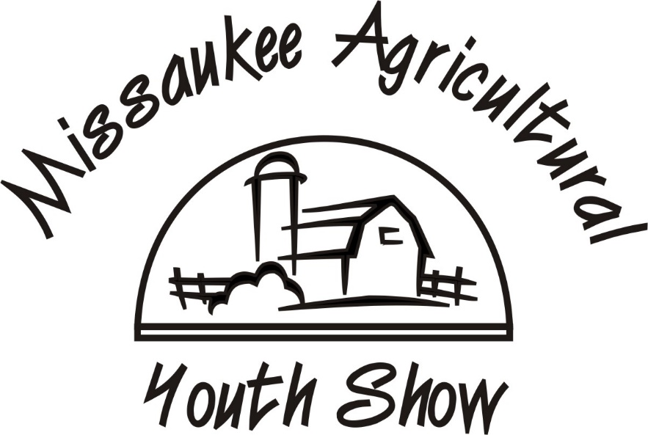
Market Rabbits
Due: July 1

Check which market animals you will be showing & selling
- Market Fryer
- Market Roaster

Exhibitor’s Name: ______________________________________________________________
Mailing Address: _______________________________________________________________
City: ___________________ Zip: ____________ Phone Number: _______________________
Age (as of Jan 1st): _____________

With my signature below, I declare my intent to exhibit the above project at the Missaukee Agricultural Youth Show.
Signature of exhibitor: ___________________________________

As the responsible adult supervising this project, I certify that the above animals are owned by the above named independent exhibitor and his/her care, being fed, watered, housed and trained primarily by the independent exhibitor.
Signature of parent or guardian: ___________________________________________________

Please send form to missaukeeyouthshow@yahoo.com OR mail to Po Box 94 Falmouth, MI 49632

Due: July 1

